# PART F – SOFTWARE USER’S MANUAL

## I. Installation Guide

### 1. Setting up the environment at server side

### Hardware requirements:

Personal computers for developing with the minimum configuration: CPU Core 2 Duo 2.0GHz, 2GB of RAM, 120GB of hard disk, and internet.

### Software requirements: (with framework ASP.NET MVC 4)

The follow software must be installed into server machine:

Windows 7 or higher versions

IIS Express 7.5 or higher versions

Microsoft SQL Server 2012 or higher versions

### 2. Deployment at server side

### Deploy database

Open SQL Server and run OATSDB\_v0.1.sql script to create database named OATSDB, then run DataOnly\_v0.1.sql script to add necessary data

### 3. Setting up the environment at client side

The client devices need to have one of the following browsers to launch the OATSDB websites:

* Mozilla Firefox 10.0 or higher
* Microsoft Internet Explorer 8.0 or higher
* Apple Safari 5.1 or higher
* Opera 15 or higher

## User‘s Guide

### General Guide

#### Register and Login

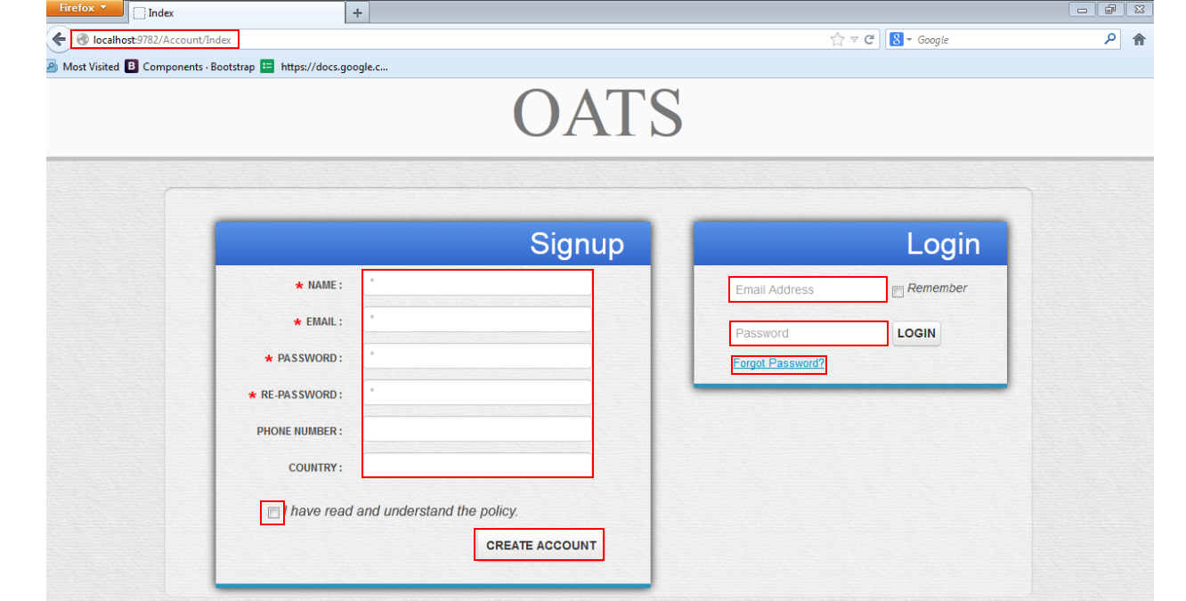

Figure : Register and Login

**Register**

Step 1: Enter the home site address

Step 2: If user want to create an account, at “Signup” board, fill following information:

+Name (required)

+Email (required)

+Password (required)

+Confirm Password (required)

+Phone Number (optional)

+Country (optional)

Step 3: Check “I have read and understand the policy” checkbox

Step 4: Click “Create Account” button

**Login**

For user have account already and want to login to site, at “login” board:

Step 1: Fill following information:

+Email (required)

+Password (required)

Step 2: Check “Remember” checkbox for remember user login later.

Step 3: Click “Login” button

Step 4: If user forgot password, Click “forgot Password” hyperlink

Enter correct email and click “Send” button, else “cancel” to return to index page.

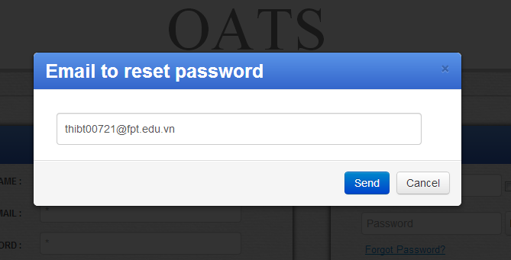

Figure : Forgot Password

### Common Guide (For both Teacher and Student Role)

#### View Tests

Here user can view all tests that available in calendar or in list

**+Calendar**

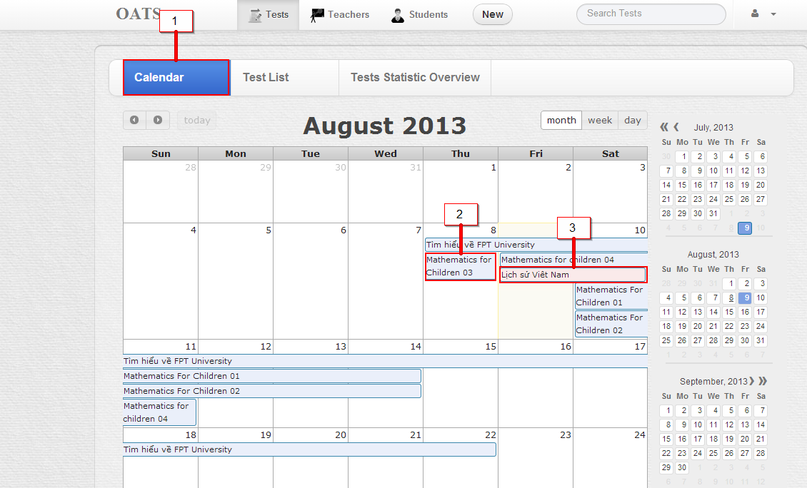

Figure : View All Tests in Calendar

Step 1: Login into system

Step 2: Click on tab “Calendar” (1)

User will see:

Test that create in “light blue” color (2)

Test that was assigned in “light red” color (3)

Notice that user can view calendar in Month, Week or Date.

**List**

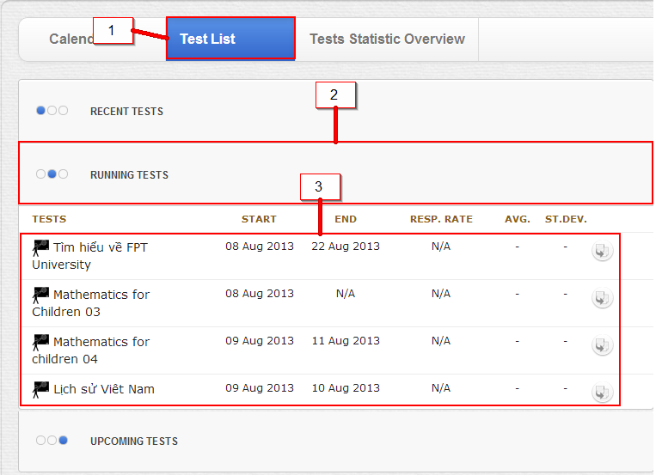

Figure : View all Tests in Lists

Step 1: Click on tab “Task List” (1)

Step 2: Click on one of three tabs: (2)

+ Recent test (test that user has done)

+Current test (test that be in time and user can do at present)

+ Upcoming test (test that will be available for user in future)

Step 3: Then user can view the test and some it’s information (3)

#### View Tests Statistic

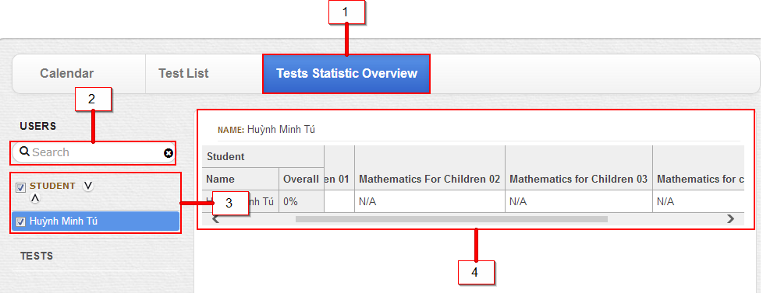

Step 1: Click on Test statistic Overview Tab (1)

Step 2: Search student for involving a student to statistic or not (2)

Step 3: make a check to particular student for involving a student to statistic or not (3)

Step 4: See the Overview of one or many student (4)

Step 5: (Search or make a Check to the test for involving a test to statistic or not)

: 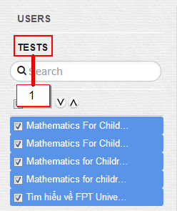

### Teacher’s Guide

#### Create Test

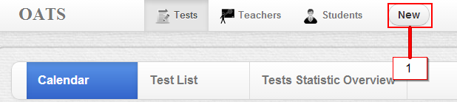

Figure : Create Test - step 1

Step 1: Login

Step 2: At index page, (default at Test “Tab”), Click button “New” (1)

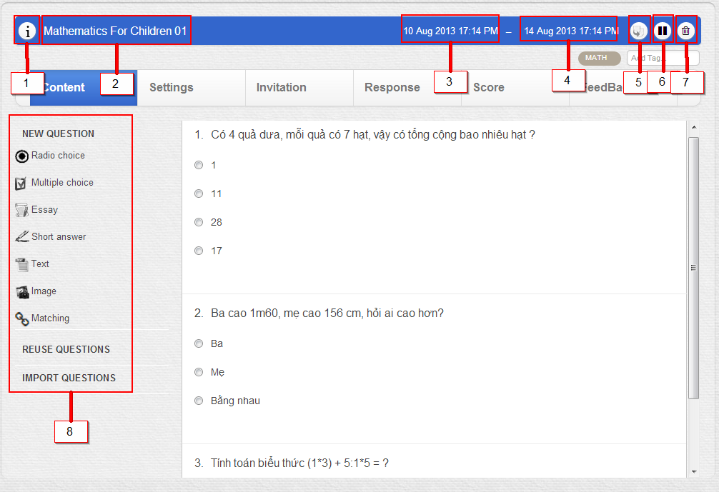

Figure : Create Test - step 2

Step 3: Click on (1) for short description.

Step 4: Enter test name (2)

Step 5: Enter start date (3)

Step 6: Enter end date (4)

Step 7: Click on the question type, or drag and drop to the next right zone for import question, then enter the question, and answer. (8)

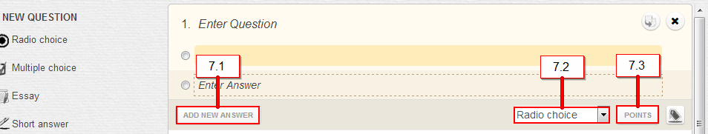

Figure : Create Test - step 3

More detail: add new answer (7.1), change question type (7.2) and add point to each answer (7.3)

**Notice:** Duplicate this test (5), Disable test (6), Delete test (7)

#### Invite other users into the test

Step1: Login

Step 2: Choose Invitation tab then click Invite more Students or Invite more Educators button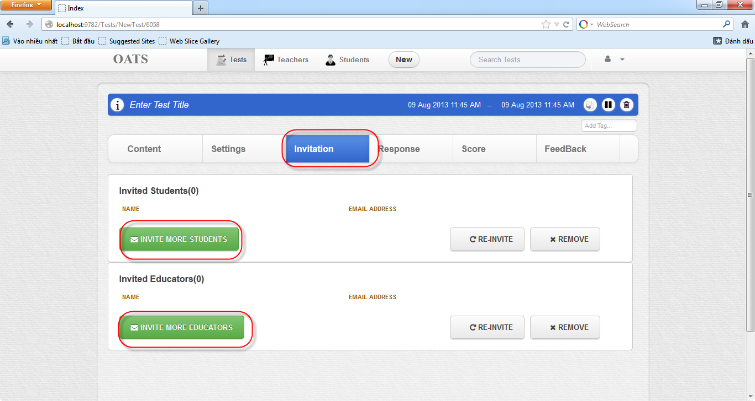

Step 3: Invite other users into the test (support search user) then click Submit button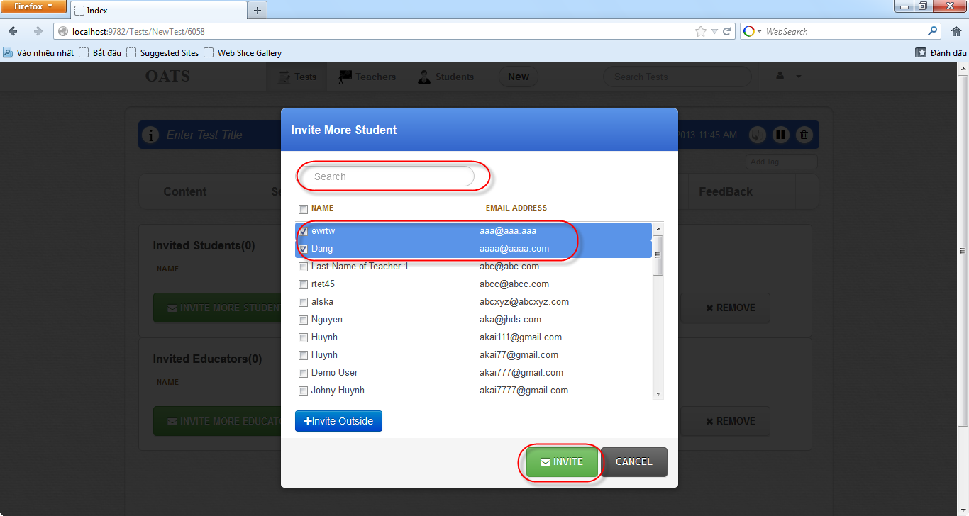

Besides, can invite people who out of system by click Invite outside then type people’s name and email who ‘re invited.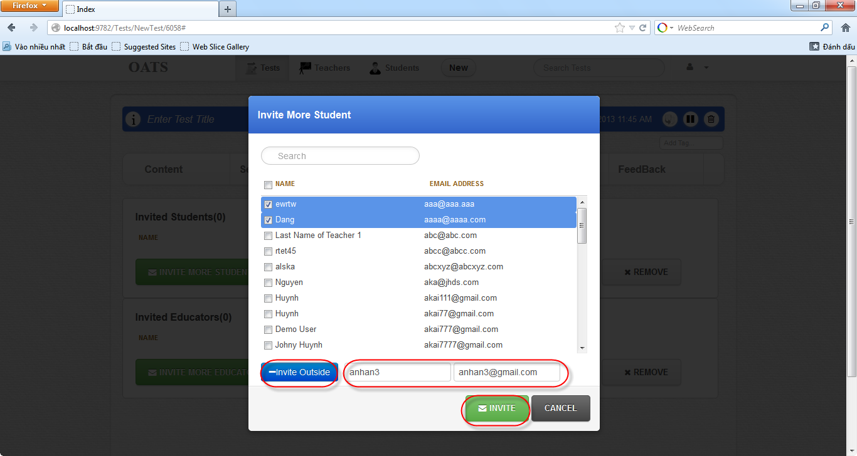

#### Review response

Step 1: Login

Step 2: Search and choose the test to review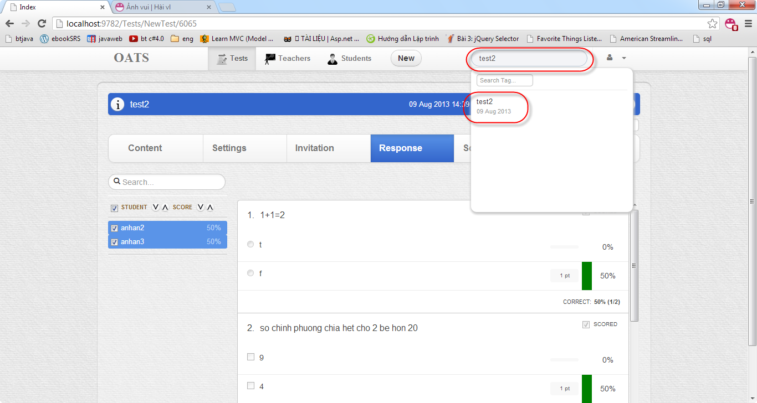

Step 3: Choose Response tab then review response and item analytics for all or some of students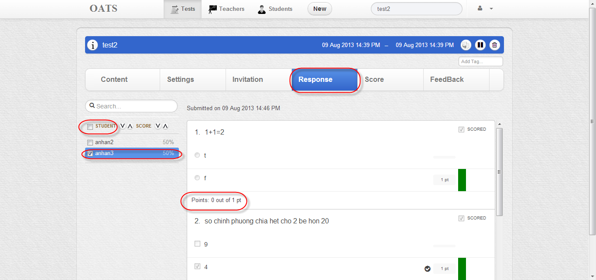

#### View Score Test

Step 1: Login

Step 2: Search and choose the test to view Score

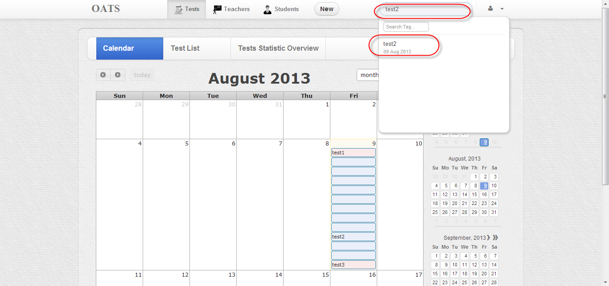

Step3: Choose Score tab then view overall or partial score of one, all or any sub set of your students.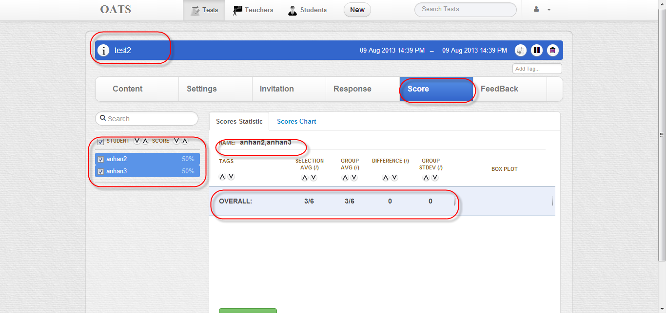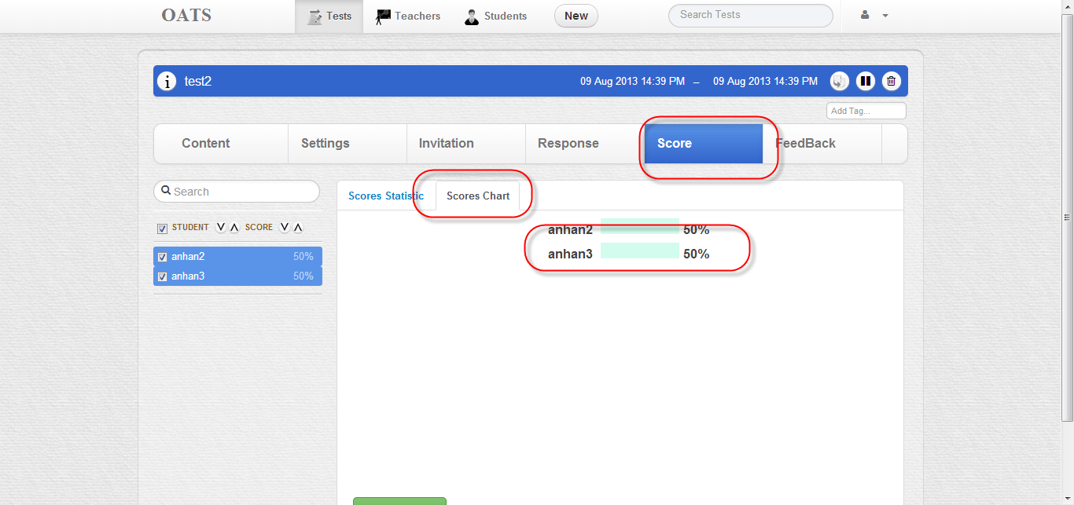

#### Configure Test

Teacher can configure tests by Settings tab:

- General Setting:

+ Mark test point: total point of the test

+ Duration Limit: Time to do test (default 10 mins).

-Test Formatting:

+ Random the order question

+ Random the order answer

+ Number questions per page (default: 5 questions) .

- Result and reporting:

+ Students can access their own score reports

-Test access control:

+Require test access code

+ Attempt limit times

Step1: Login

Step 2: Choose Settings tab

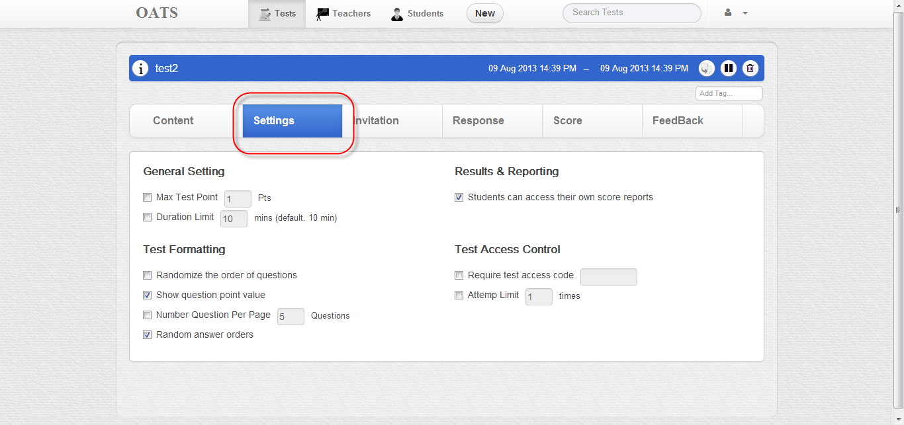

Step 3: Configure a test 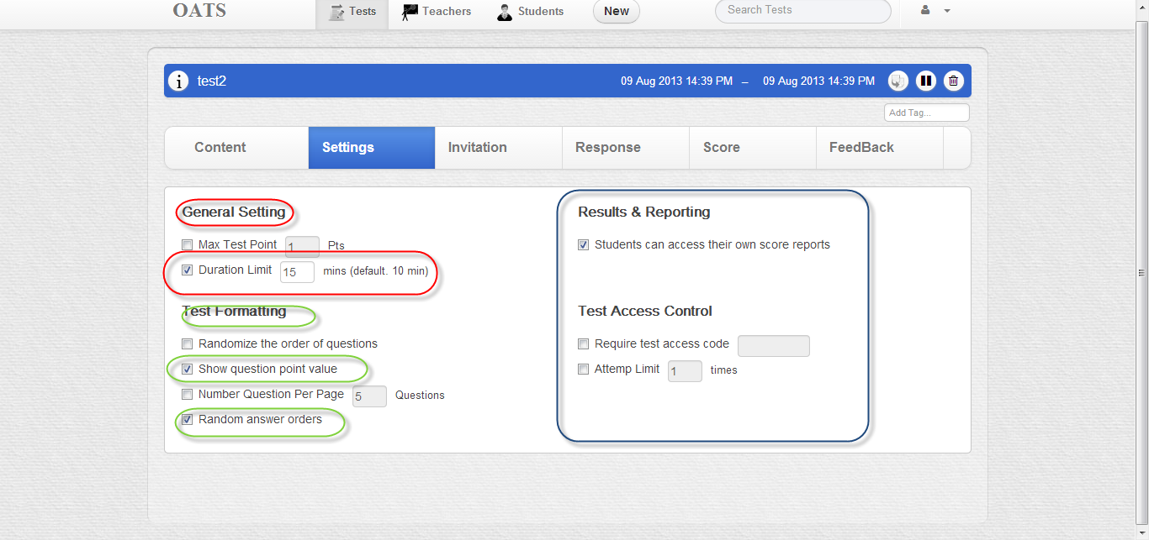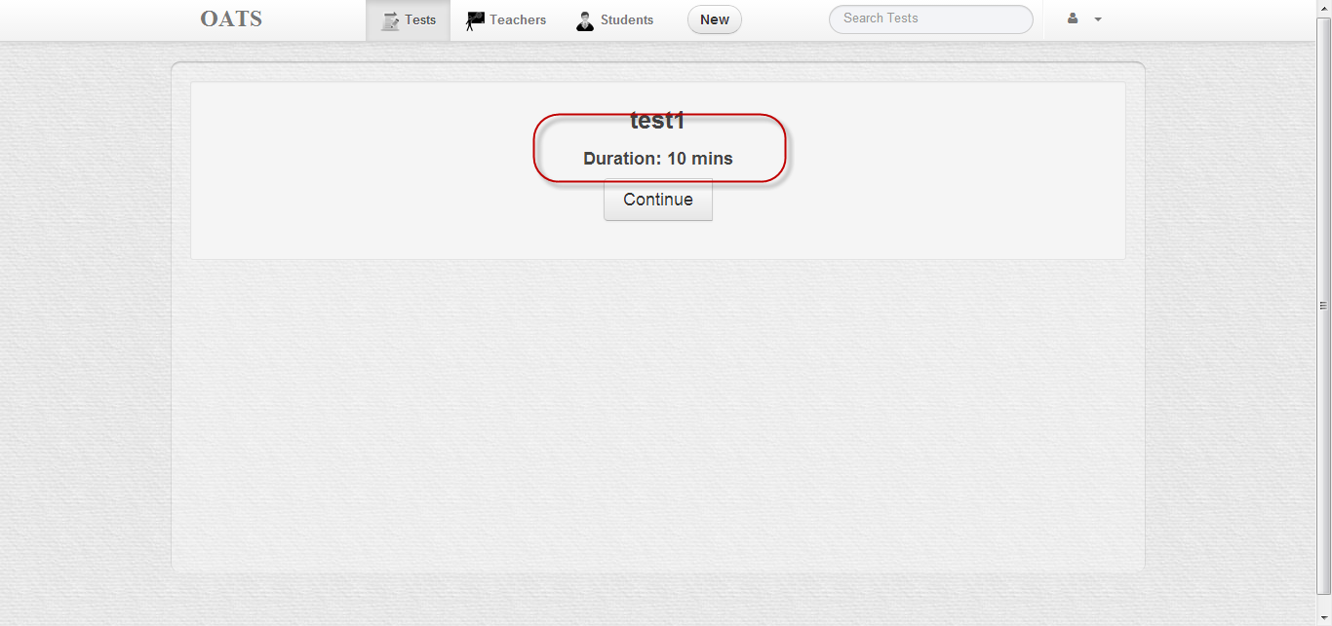

#### Assign or Un-assign Tests for Student

Step 1: Login

Step 2: Search user (student) who want to assign tests

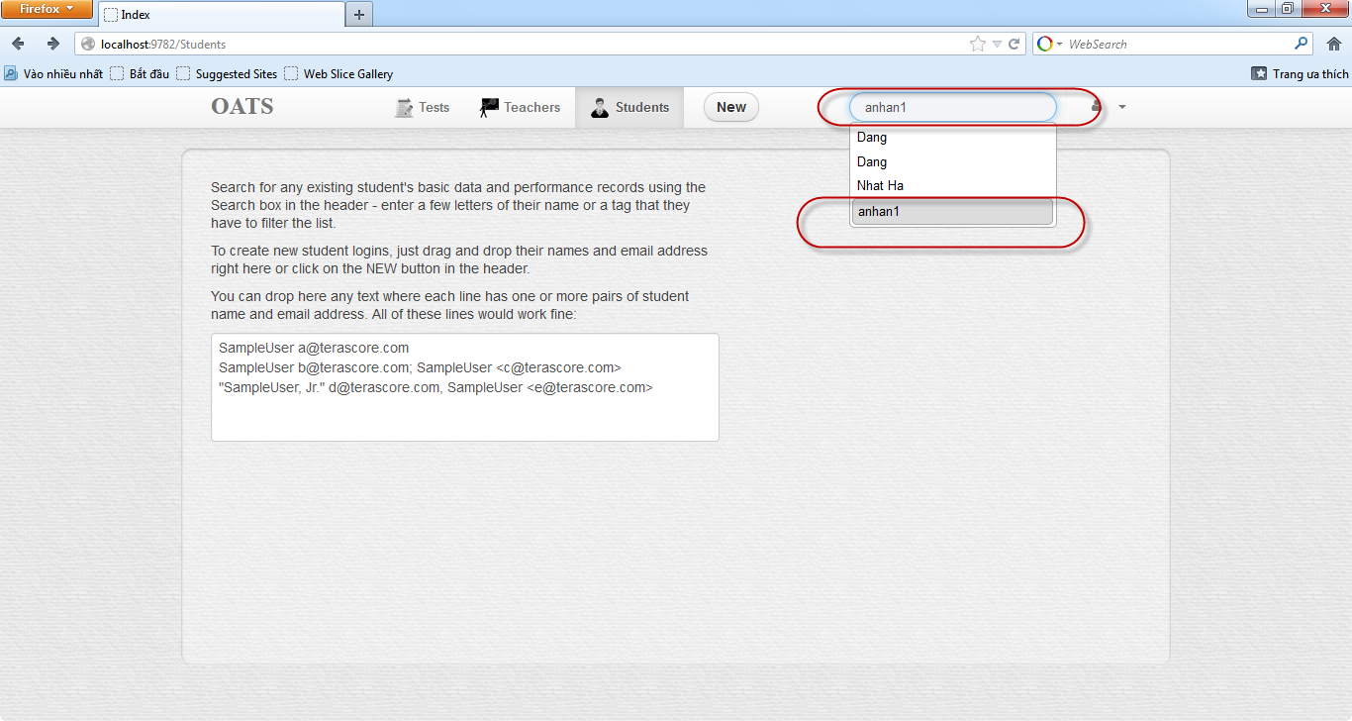

Step 3: Search tests which want to assign to student

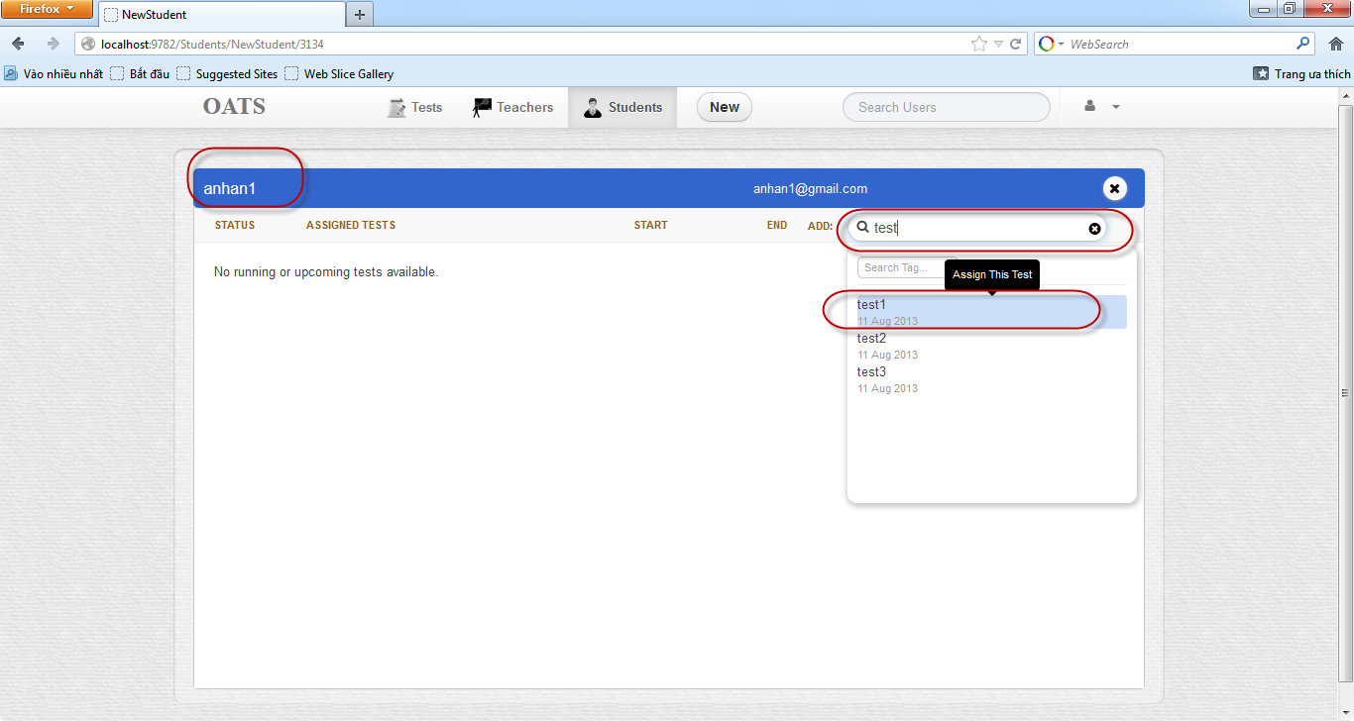

Step 4: the tests were assigned to student

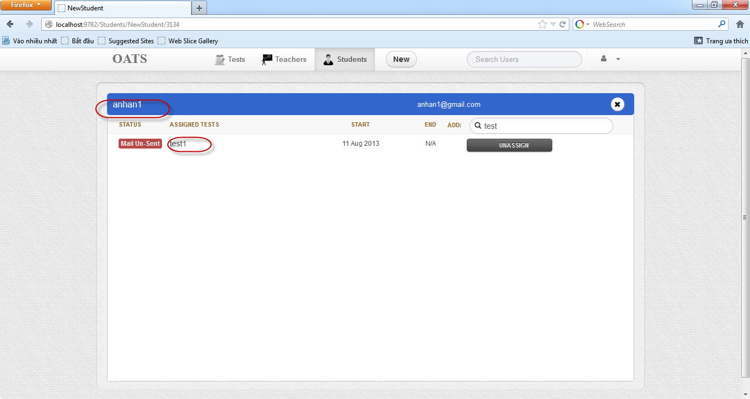

Step 5: Un-assign the tests for user .Click Un-assign button

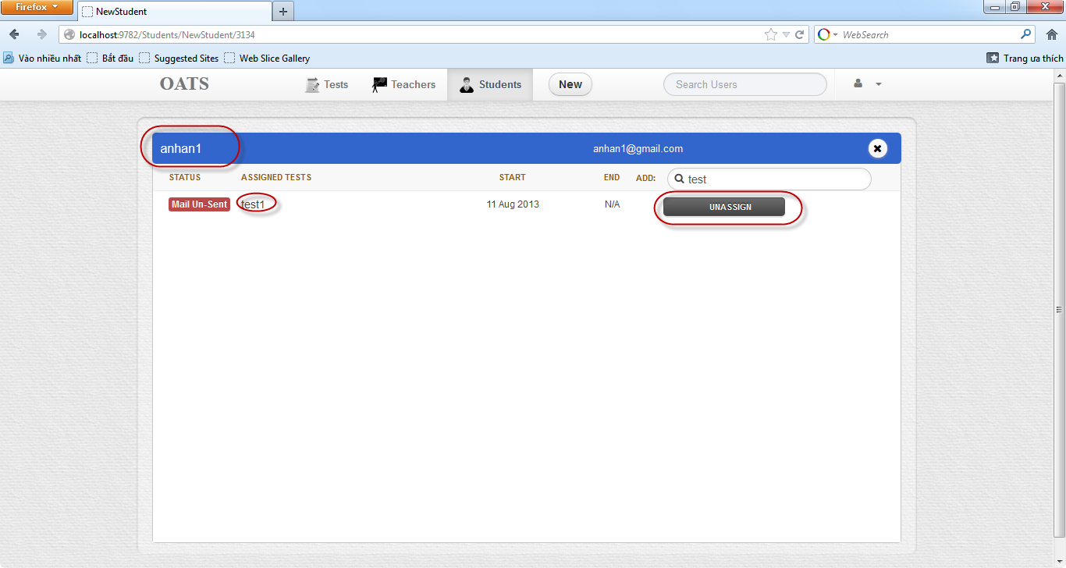

#### Feedback

Teacher can feedback his students’ tests.

Step 1 login

Step2: Choose the test which want to feedback

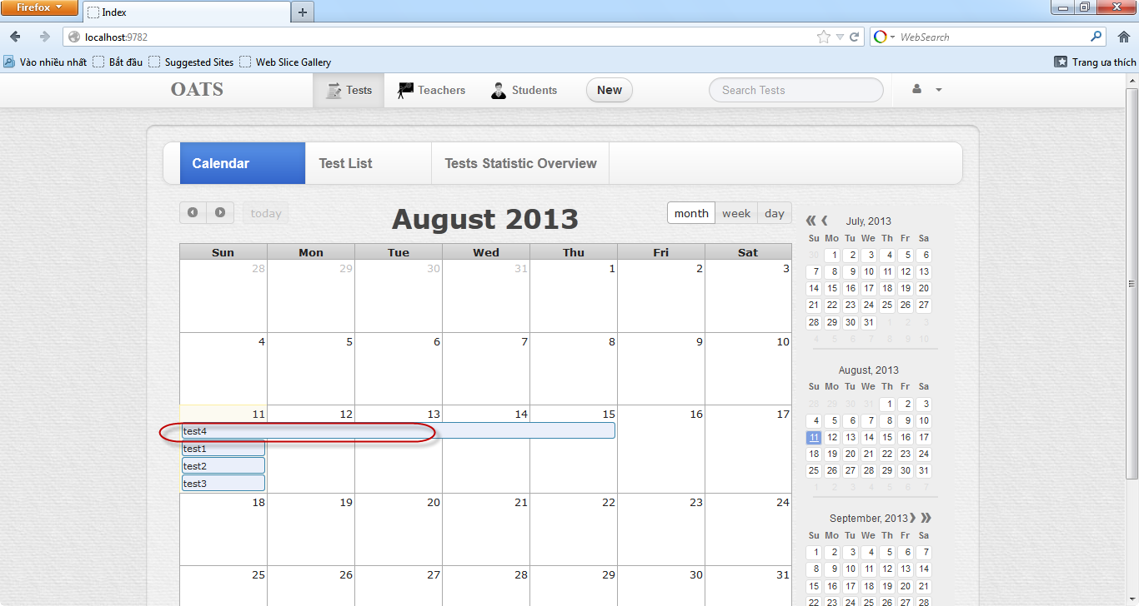

Step 3: Choose Feedback tab

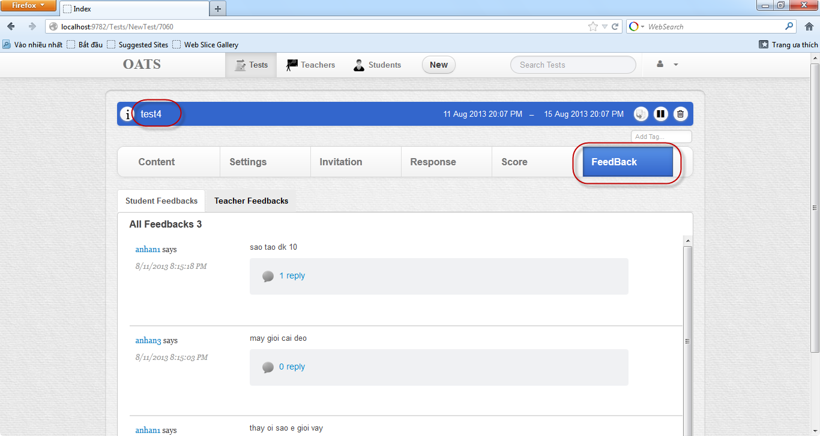

Step 4: Feedback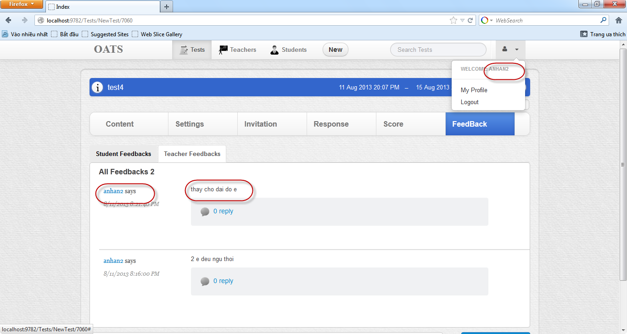

### Student’s Guide

#### Do Test

There are 2 ways:

First:

Step 1: Login

Step 2: Choose a test which its background color is red to do in Calendar tab.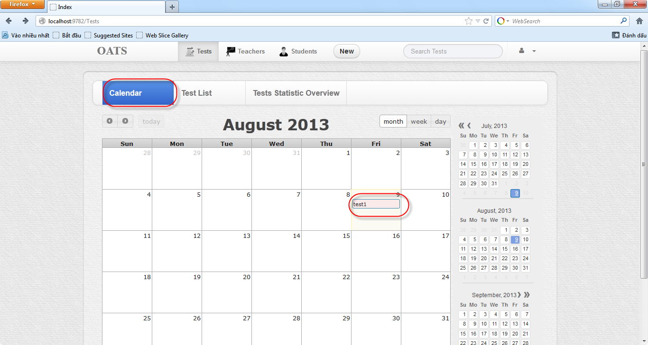

Step 3: Click Continue

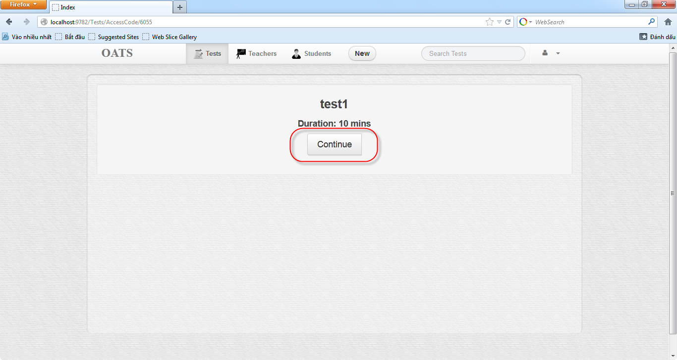

Step 4: Do test and finish

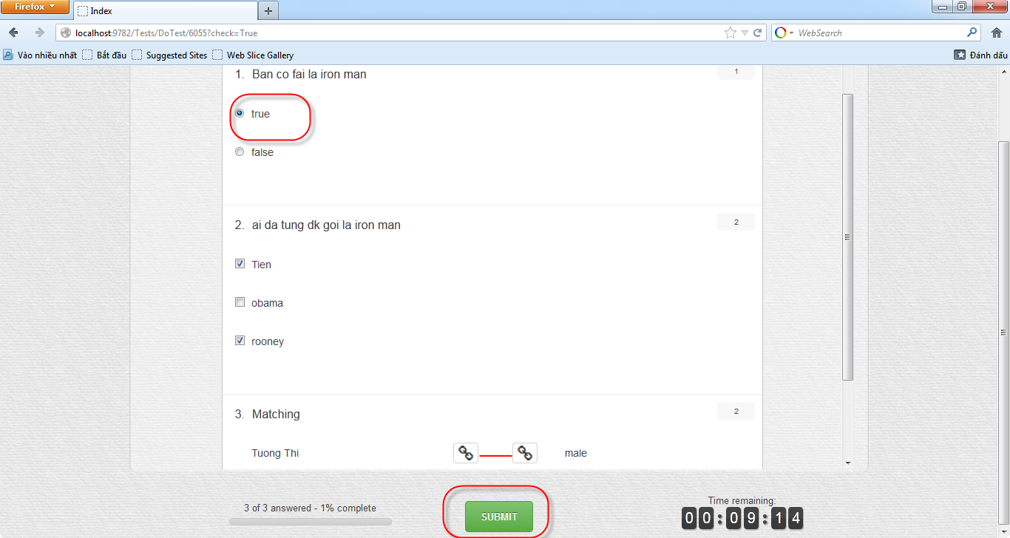

Second:

Step 1: Login

Step 2: Choose a test which has tooltip message “Take a test” , to do this test.

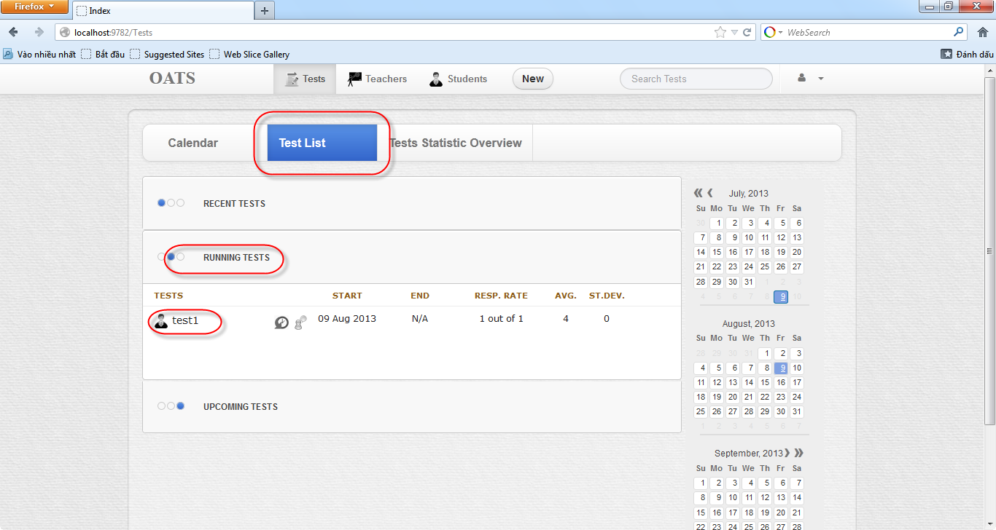

Step 3: Click Continue



Step 4: Do test and finish



#### View History Test

Step 1: Login

Step 2: Choose Test List tab then click the test’s D:\Capstone Project\SourceCode\OATS_Capstone\OATS_Capstone\Style\img\test_history.png icon 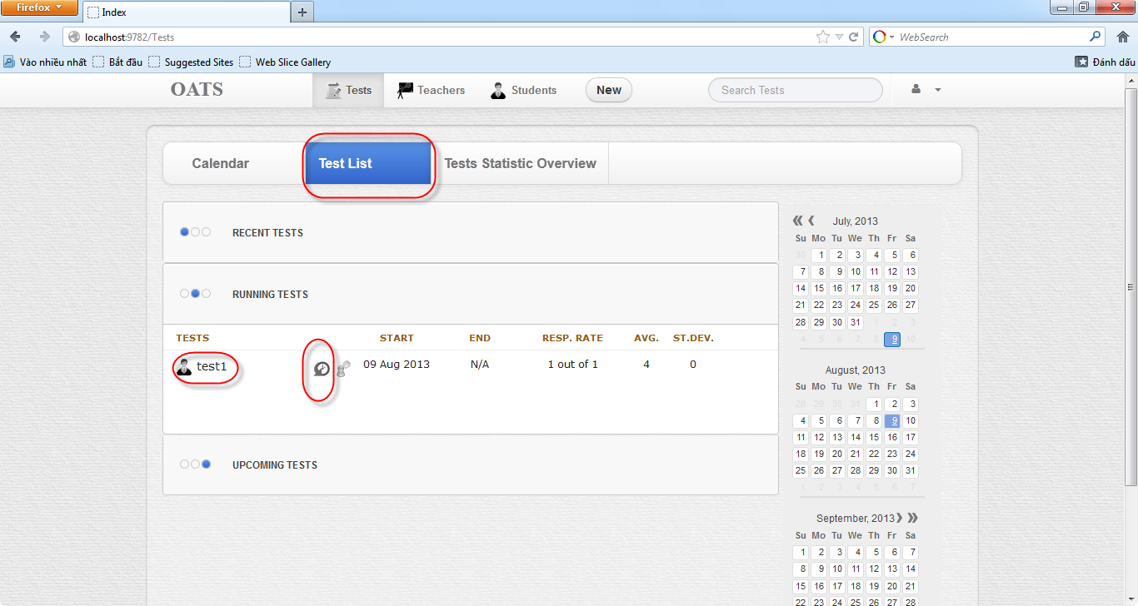

Step 3: Review the test did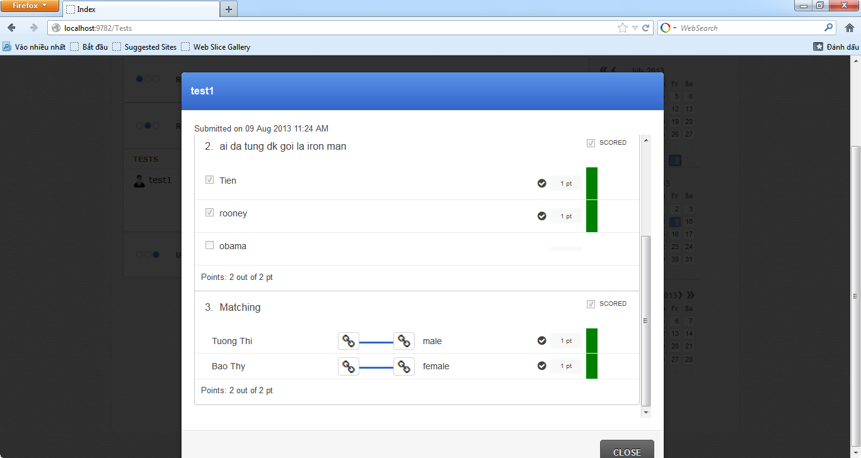

#### Search Test

Step 1: Login

Step 2: Type test name into Search Tests textbox(can search by tag) then choose the test 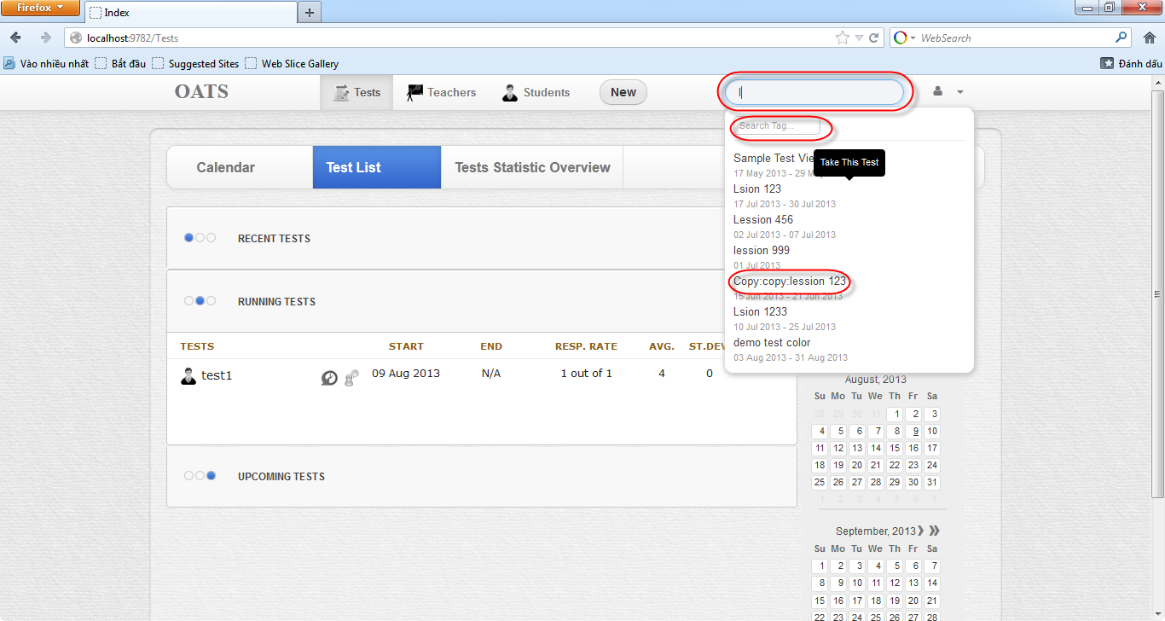

Step 3: Appear the test

#### Update Profile

Step 1: Login

Step 2: Click D:\Capstone Project\SourceCode\OATS_Capstone\OATS_Capstone\Style\img\user.png icon then choose My Profile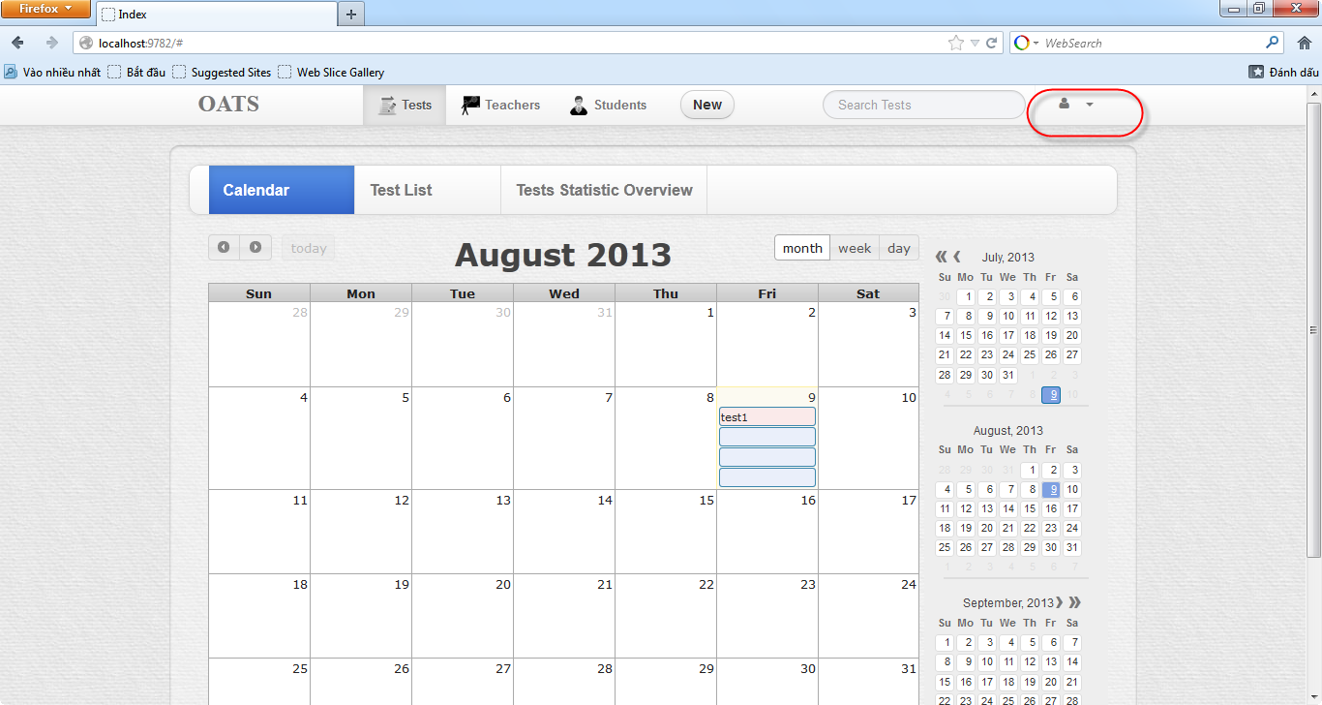

Step 3: Update Profile 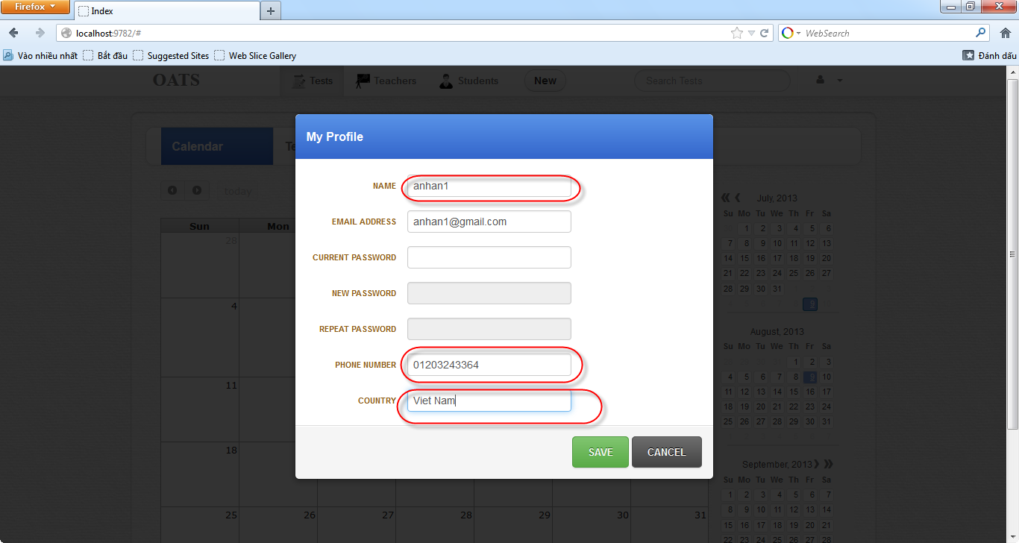

#### Feedback

Step 1: Login

Step 2: Choose the test which want to Feedback

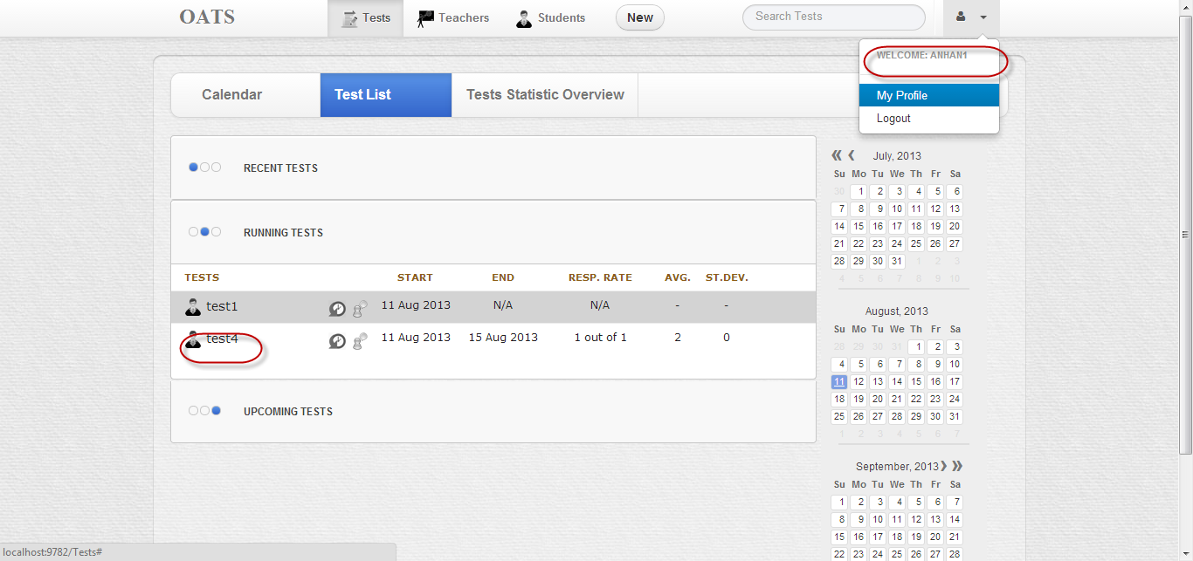

Step 3: Click D:\Capstone Project\SourceCode\OATS_Capstone\OATS_Capstone\Style\img\feedback.pngicon

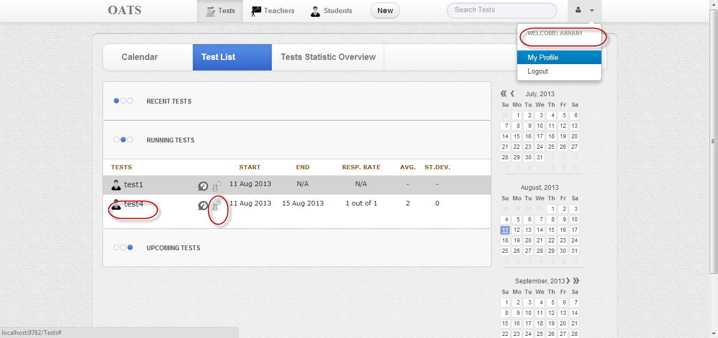

Step 4: Feedback

